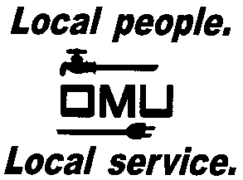

REQUEST FOR PROPOSAL

Owensboro Municipal Utilities will receive proposals until 2:00 P.M. (CST) on XXXX, 2019 (prevailing time) at which time proposals are to be received via hard copy or e-mail.

RFP 1908-01
COMPENSATION AND BENEFIT PROGRAM REVIEW

Owensboro Municipal Utilities of Owensboro, Kentucky is seeking proposals for consulting services to perform a comprehensive review of its compensation program and wages. OMU desires to maintain a compensation program and pay structure that is competitive with the regional utility and industrial markets and encourages maximum performance.

Prospective vendors may obtain copies of the proposal specifications by contacting

Louise Keach, Purchasing and Inventory Manager, at the Training and Development Center, 1531 East 4th Street, Owensboro, KY @ 270-691-4399 or via e-mail: keachel@omu.org.

