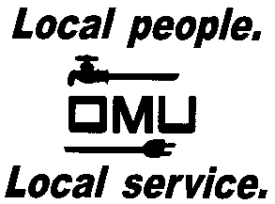
Owensboro Municipal Utilities

Request for Proposal
Owensboro Municipal Utilities will receive proposals until 3:00 pm CST on Friday, November 15, 2019 (prevailing time) at which time proposals are to be received via hard copy.

Benefit Advisor Services

Owensboro Municipal Utilities (OMU) will be seeking proposals for a benefit advisor to partner with to provide guidance and services with core employee benefit products, claims management, compliance, and administration of benefits.

Prospective bidders may obtain copies of the Request for Proposal by contacting Dana Wilson, Human Resource Manager, via email: wilsondl@omu.org.

OMU reserves the right to reject any or all proposals and to waive irregularities.

