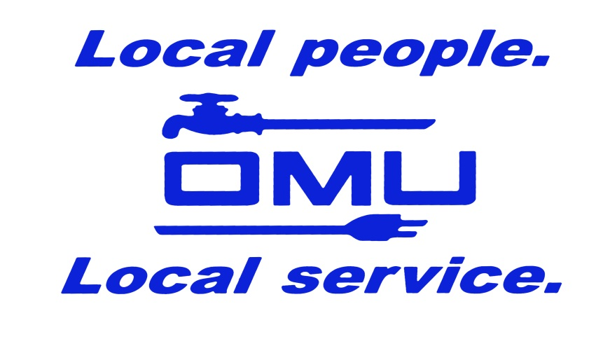

Coal Combustion Residuals Fugitive Dust Control Report

FOR

ELMER SMITH STATION
OWENSBORO MUNICIPAL UTILITIES

4301 State Route 144
Owensboro, KY 42303

December 30, 2019

TABLE OF CONTENTS
Section Page
1.0 INTRODUCTION 1
1.1 Purpose of the Report (40 CFR 257.80(c)) 1
1.2 Accessibility of the Annual CCR Fugitive Dust Control 2
Report (40 CFR 257.80(d))
1.2.1 Placement in Operating Record 2
1.2.2 Publicly Accessible Internet Site Requirements 2
1.2.3 Notification Requirements 2
2.0 SUMMARY OF CCR FUGITIVE DUST CONTROL MEASURES 3
(40 CFR 257.80(b)(1))
2.1 Paved Roads, Lots, and Parking Areas 3
2.2 Unpaved Roads and Areas 3
2.3 Bottom Ash Handling 4
2.4 Fly Ash Handling 4
2.5 Ash Settling Basins and Dewatering Area 4
2.6 Synthetic Gypsum Handling 5
2.7 List of all CCR Dust Controls 5
3.0 RECORD OF CITIZEN COMPLAINTS 6
4.0 CORRECTIVE MEASURES TAKEN 7
Appendices
A Citizen Complaints Log Form 8

INTRODUCTION
In accordance with the Disposal of Coal Combustion Residuals (CCR) from Electric Utilities final ruling published in the Federal Register April 17, 2015, Owensboro Municipal Utilities (OMU) is required to publish an Annual CCR Fugitive Dust Control Report within 14 months after placing the initial CCR Fugitive Dust Control Plan in the facility’s operating record. The deadline for completing subsequent reports is one year after the date of completing the previous report.

1.1 Purpose of the Report (40 CFR 257.80(c))
This Annual Coal Combustion Residual (CCR) Fugitive Dust Control Report has been prepared to meet the requirements of and Title 40, Code of Federal Regulations, Part 257, subpart 80 (40 CFR 257.80). The purpose of this report is to provide an outline of procedures implemented by Owensboro Municipal Utilities’ Elmer Smith Station (ESS) to prevent fugitive CCR emissions from occurring as well as a record of citizen complaints and a summary of corrective measures taken to maintain compliance with aforementioned regulatory requirements.

1.2 Accessibility of the Annual CCR Fugitive Dust Control Report (40 CFR 257.80(d))
Owensboro Municipal Utilities must comply with the recordkeeping requirements as described in the final rule.

1.2.1 Placement in Operating Records
In accordance with 40 CFR 257.80(d), a complete copy of this Annual CCR Dust Control Report including citizen complaints and all associated records are maintained at the facility in the library located on the third floor of the office building. The front office is attended Monday through Friday 8 AM to 4:30 PM.

1.2.2 Publicly Accessible Internet Site Requirements
In accordance with CFR 257.80(d), OMU will post to the publicly accessible internet site the Annual CCR Fugitive Dust Control Plan, subsequent amendments, and CCR Annual Fugitive Dust Control Reports within 30 days of being placed in the operating record.

1.2.3 Notification Requirements
In accordance with CFR 257.80(d), OMU will notify the State Director when the Annual CCR Fugitive Dust Control Report is placed in the operating record and posted Owensboro Municipal Utilities website.

Summary of CCR Fugitive Dust Control Measures (40 CFR 257.80(b)(1))
Owensboro Municipal Utilities’ Elmer Smith Station has implemented fugitive dust control measures which are outlined in Section 3.0 of the Fugitive Dust Control Plan and restated below. The Plan is also readily accessible in the facility operating record as well as a publicly accessible internet site (https://omu.org/coal-combustion-residuals-ccr-rule-compliance-data-and-information/).

2.1 Paved Roads, Lots, and Parking Areas
Plant roadways that are subject to regular vehicle traffic, parking areas, and much of the areas surrounding the plant are paved. In order to further reduce potential sources of CCR and non-CCR fugitive emissions these paved surfaces are swept as needed with a truck mounted street sweeper. Paved roads that have dust on them are treated with street flusher water sprays from a water truck as needed to reduce fugitive dust. Additionally, roads at the plant have a posted vehicle speed limits of 15 and 5 miles per hour. This speed limit is observed and enforced by plant security personnel.
Street sweeping was selected to clean roadways, lots, paved because it removes dust and debris from the paved areas therefore removing dust that could become fugitive. Water spray is used to wet sections of paved roads that are near areas of unpaved roads that receive dust from the adjacent unpaved areas. These areas also receive cleaning with the street sweeper and receive water sprays as they are next to the unpaved areas that receive the majority of water spraying and the water spraying covers a larger area in a quicker manner to alleviate traffic emission of fugitive dusts allowing the street sweeping to concentrate on certain affected areas. The vehicular speed limit was implemented not only as a way to reduce fugitive dust creation, but for safety as well.

2.2 Unpaved Roads and Areas
Roadways that are not paved receive limited traffic. These roads are watered with water spray from a water truck as needed in order to reduce emissions of fugitive dust.
This method was selected because it has proven to be the most effective at preventing fugitive dust. Chemical dust suppressants have been used in the past but have been problematic when they are spread by vehicular traffic onto paved area. This makes the paved areas harder to clean. Oils, tree sap, or other treatment chemicals could also be washed into the runoff or settling ponds which could introduce unwanted pollutants to our water discharge.

2.3 Bottom Ash Handling
Bottom ash is removed from the boilers via a wet system that is fully enclosed and sluiced with water. This eliminates the likelihood of fugitive emissions in transport to the ash settling basins.
Fugitive dust control was incorporated into the engineering of this system; because of this no additional operational controls are necessary.

2.4 Fly Ash Handling
Fly ash is collected in electrostatic precipitators and conveyed via a fully enclosed system to silos for dry storage, or if silos are full or unavailable for service, ash is sluiced with water to the ash pond #2 through a basaltic lined ash pipe. Fugitive dust emissions are controlled by utilizing fully enclosed conveying systems for wet and dry collection.
Fugitive dust control was incorporated into the engineering of this system; because of this no additional operational controls are necessary

2.5 Ash Settling Basins and Dewatering Activities
Ash sluiced to the ash pond is removed from the ash pond by a dragline or long reach excavator and deposited into a small holding cell for some dewatering, the ash is removed from this initial holding cell by an excavator and deposited into the front edge of our dewatering pile, and then this material is picked up by an excavator again and restacked/deposited on the north face of the pile., Dewatered material is loaded in tarped dump trucks for transport off site. Due to the nature of the process, materials that have lost the most moisture are suitable to be shipped offsite for disposal and are promptly removed, this process keeps ash pile wet, therefore minimizing the likelihood of fugitive emissions. Because this is largely a wet process there have not been any fugitive dust issues with this process. The only operational controls that have been employed are the tarping of the trucks that haul dewatered ash off-site.

2.6 Synthetic Gypsum Handling
Synthetic gypsum is collected and dewatered mechanically in the FGD building. This is a wet process located inside of an enclosed building, eliminating the chances of fugitive emissions. The dewatered synthetic gypsum is then conveyed in an enclosed conveyor system to a partially enclosed storage building, and minimum fall distances from conveyor belts is maintained. Synthetic gypsum is loaded out of this building via tarped trucks. The synthetic gypsum can then be transported from this storage building in trucks to the barge load-out located on the river at the northeast edge of the property. The barge load out utilizes a covered conveyor to load synthetic gypsum into barges, using a minimal material drop through a lowering chute to the barge level. The use of enclosed dewatering, covered conveyors, partially enclosed storage building and minimized material fall distances, are designed to reduce fugitive emissions.

2.7 List of all CCR Dust Controls
- Street sweeping truck
- Water truck with water sprays
- (2) Fly ash silos with 99.9%+ dust collectors
- Synthetic gypsum storage building
- CCR Transport truck tarps
- Enclosed gypsum dewatering process
- Reduced vehicle speed limits
- Wet bottom ash collection system

Record of Citizen Complanints
There were no citizen complaints to report as can be seen in Appendix A.

Corrective Measures Taken
No corrective measures were necessary.

APPENDIX A
Citizen Complaint Log Form
