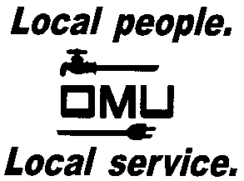

REQUEST FOR PROPOSAL

Owensboro Municipal Utilities will receive sealed bids until 2:00 P.M. (CDT) (prevailing time) on January 16, 2018 at which time bids will be opened and acknowledged:

OMU BID No. 18-01-003
OMU CAVIN WATER TREATMENT PLANT PIPE COATING MAINTENANCE

Owensboro Municipal Utilities (OMU) requests proposals to recoat select areas of piping within
the Cavin Water Treatment Plant.

A MANDATORY Pre-Bid & Site Visit will be held at 10:00 A.M. CST on January 4, 2018at the
Cavin Plant located at 4067 State Route 144, Owensboro, KY 42303. The meeting will explain
the workscope and address any questions potential bidders may need clarifying. Only those bidders in representatives in attendance will be considered for possible bid award.

Prospective bidders may obtain copies of the bid documents and specifications by sending an e-mail with your Company Name and a brief description of your business. Contact Louise Keach, Purchasing and Inventory Manager, via e-mail: keachel@omu.org.

OMU reserves the right to reject any or all bids and to waive irregularities.

