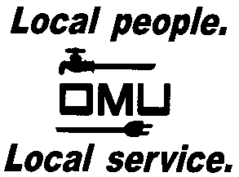

INVITATION TO BID

Owensboro Municipal Utilities will receive sealed bids until 2:00 P.M. (CST) on August 31, 2017, (prevailing time) at which time bids will be opened and read aloud for the:

BID No. 17-08-055
FORKLIFT

Prospective bidders are invited to submit a bid for a new, unused lift truck, along with three alternates; one new dual tire, one used 2014 year model or newer dual tire, and one used 2010-2013 year model dual tire. The forklift is to be able to maneuver easily on gravel as well as concrete.

BID OFFERINGS ON THE FOLLOWING MODELS WILL BE ACCEPTED: NISSAN, CATERPILLAR, YALE, CLARK, HYSTER, CROWN, MITSUBISHI, AND TOYOTA.

Prospective bidders may obtain copies of the bid documents and specifications by sending an e-mail with your Company Name and a brief description of your business. Contact Louise Keach, Purchasing and Inventory Manager, via e-mail: keachel@omu.org.

OMU reserves the right to reject any or all bids and to waive irregularities.

