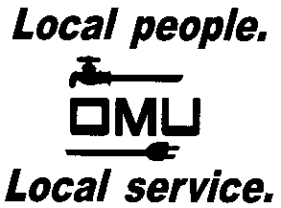

REQUEST FOR PROPOSAL

Owensboro Municipal Utilities will receive sealed bids until 11:00 A.M. (CDT) (prevailing time) on October 27, 2016 at which time bids will be opened and acknowledged:

OMU BID No. 16-10-058
OMU MOBILE MANAGEMENT SYSTEM

Owensboro Municipal Utilities (OMU) requests proposals for a Mobile Management Solution to replace its paper solution. This new solution is expected to facilitate near real-time electronic communications between field crews and operations’ personnel in the office. The acceptable solution will synchronize between Cogsdale’s Work Order system and the Mobility solution.

Prospective bidders may obtain copies of the bid documents and specifications by sending an e-mail with your Company Name and a brief description of your business. Contact Louise Keach, Purchasing and Inventory Manager, via e-mail: keachel@omu.org.

OMU reserves the right to reject any or all bids and to waive irregularities.

