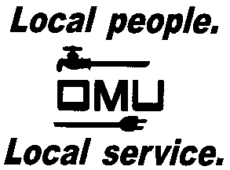

INVITATION TO BID

Owensboro Municipal Utilities will receive sealed bids until 2:00 P.M. (CST) on May 22, 2018 (prevailing time) at which time bids will be opened and read aloud for the:

BID No. 18-05-017
Water Crew Truck

Owensboro Municipal Utilities is requesting sealed bids from Bidders who wish to bid on a Water Crew Truck. Bidders may bid on the complete truck. Bidders may also bid on only the cab & chassis or just the custom utility bed.

Prospective bidders may obtain copies of the bid documents and specifications by sending an e-mail with your Company Name and a brief description of your business. Contact Derek Price, Buyer, via e-mail: pricedm@omu.org.

OMU reserves the right to reject any or all bids and to waive irregularities.

