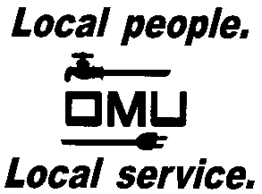

INVITATION TO BID

Owensboro Municipal Utilities will receive sealed bids until 2:00 P.M. (CST) on May 1, 2018 (prevailing time) at which time bids will be opened and read aloud for the:

BID No. 18-04-015
SAFETY AND TOOL INVENTORY ANNUAL

Owensboro Municipal Utilities is requesting bids for safety and tool inventory for our warehouse. OMU’s approved manufacturers list are included in the bid. No exceptions to manufacturers will be accepted. These items are to be new, not used items.

Prospective bidders may obtain copies of the bid documents and specifications by sending an e-mail with your Company Name and a brief description of your business. Contact Derek Price, Buyer, via e-mail: pricedm@omu.org.

OMU reserves the right to reject any or all bids and to waive irregularities.

