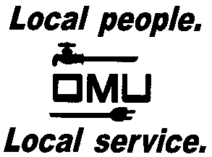

INVITATION TO BID

Owensboro Municipal Utilities will receive sealed bids until 2:00 P.M. (CST) on July 11, 2017 (prevailing time) at which time bids will be opened and read aloud for the:

17-07-042
LINE TRUCK WITH 55 FOOT BOOM (MODIFIED)

Owensboro Municipal Utilities is requesting bids for the purchase (1) New Cab & Chassis and Line Body with Articulating Side by Side Overcenter aerial device with an insulating lower arm, insulating upper boom, and a 24 inch Vertical Lift Platform.

Prospective bidders may obtain copies of the bid documents and specifications by sending an e-mail with your Company Name and a brief description of your business. Contact Derek Price, Buyer, via e-mail: pricedm@omu.org.

OMU reserves the right to reject any or all bids and to waive irregularities.

