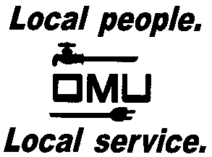

INVITATION TO BID

Owensboro Municipal Utilities will receive sealed bids until 2:15 P.M. (CST) on May 11, 2017 (prevailing time) at which time bids will be opened and read aloud for the:

17-05-027
LINE TRUCK WITH 41 FOOT BOOM

Owensboro Municipal Utilities is requesting bids for the purchase (1) New Cab & Chassis with Articulating Telescopic Aerial Device, a fiberglass upper boom and fiberglass insulator in the articulating arm, proportional joystick upper controls, and 24 Inch Vertical Lift Platform.

Prospective bidders may obtain copies of the bid documents and specifications by sending an e-mail with your Company Name and a brief description of your business. Contact Derek Price, Buyer, via e-mail: pricedm@omu.org.

OMU reserves the right to reject any or all bids and to waive irregularities.

