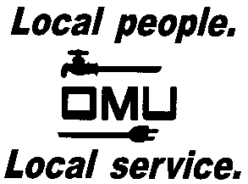

INVITATION TO BID

Owensboro Municipal Utilities will receive sealed bids until 2:00 P.M. (CST) on September 8, 2016, (prevailing time) at which time bids will be opened and read aloud for the:

OMU BID NO. 16-09-049
DUMP TRUCK TRANSPORTATION AND HAULING OF COAL COMBUSTION RESIDUALS

Owensboro Municipal Utilities is requesting bids for the Hauling of Coal Combustion Residuals (CCR) or by-product materials to areas designated for placement of the materials generated at the Elmer Smith Generating Station.

Prospective bidders may obtain copies of the bid documents and specifications by sending an e-mail with your Company Name and a brief description of your business. Contact Louise Keach, Purchasing and Inventory Manager, via e-mail: keachel@omu.org.

OMU reserves the right to reject any or all bids and to waive irregularities.

