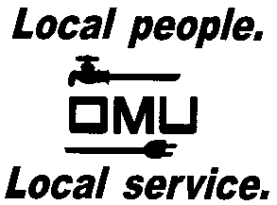

INVITATION TO BID

Owensboro Municipal Utilities will receive sealed bids until 2:30 P.M. (CST) on June 21, 2016 (prevailing time) at which time bids will be opened and read aloud for the:

BID No. 16-06-036
OMU BORING MACHINE RENTAL/LEASE

Owensboro Municipal Utilities, a municipal power distributor and telecom service provider, is requesting a rental/lease for a Ditch With JT20 Jet Trace Boring Machine.

Prospective bidders may obtain copies of the bid documents and specifications by sending an e-mail with your Company Name and a brief description of your business. Contact Louise Keach, Purchasing and Inventory Manager, via e-mail: keachel@omu.org.

OMU reserves the right to reject any or all bids and to waive irregularities.

